Important changes to the [Community Name] flood hazard maps are underway. As floodplain boundaries, regulatory flood elevations and vertical datums change, so may how you design and construct your buildings and develop your property, now and in the future. So be sure to stay informed.
[COMMUNITY NAME] FLOOD MAPS
ARE CHANGING
In [month, year], the Georgia Environmental Protection Division (EPD), under the Department of Natural Resources, and the Federal Emergency Management Agency (FEMA) will be releasing new preliminary flood hazard maps, known as Flood Insurance Rate Maps (FIRMs), for [specific watersheds/all of County Name]. The new FIRMs will show the extent to which newly mapped areas of the county are currently at risk for flooding.
The remapping effort—part of FEMA’s nationwide Risk Mapping, Assessment and Planning (Risk MAP) effort—was necessary because flood hazard and risk information shown on the flood maps need to be updated. Detailed studies in some areas are over [years] old. Since then, the drainage patterns have changed, new land development has occurred, and mapping and modeling technology has significantly improved.
These new flood maps will provide builders, developers, engineers, and others with up-to-date, reliable,
Internet-accessible information about [community’s] flood risk on a property-by-property basis.
UNDERSTANDING THE EFFECTS
While the FIRMs may not become effective for another [number] months or more, it is important for professionals in the building industry to understand what the changes
in the new maps are and what they mean. These changes may not only affect how and where they can build but there may be implications to the federal flood
insurance requirements.
CHANGES IN FLOOD ZONE
AND ELEVATION
It is crucial for both building professionals and their clients to know if the property being remodeled, built on or planned to be built on is currently in a moderate- or low-risk area (shown on the flood maps as a “B”, “C”, or “X” zone) and will be identified to be in a higher risk zone (shown as an “A” [or “V”] zone), or if there is a planned change in the Base Flood Elevation (BFE). As FEMA releases [community name’s] preliminary flood maps (FIRMs) for public review, building professionals should review them to see what changes are occurring where and when the changes will become effective.
Knowing in advance if a property is being identified as being in a higher risk flood zone or a higher BFE will help ensure that the building is built to the newer, safer federal standard when the maps become effective. [Note that in community/county name, the more restrictive BFE is used as best available data when the preliminary maps are released/the final new maps are adopted.] Knowing the changes in BFE and flood zone in advance can also allow
for the building to be constructed high enough above the BFE to provide savings in flood insurance premiums to the ultimate owner.
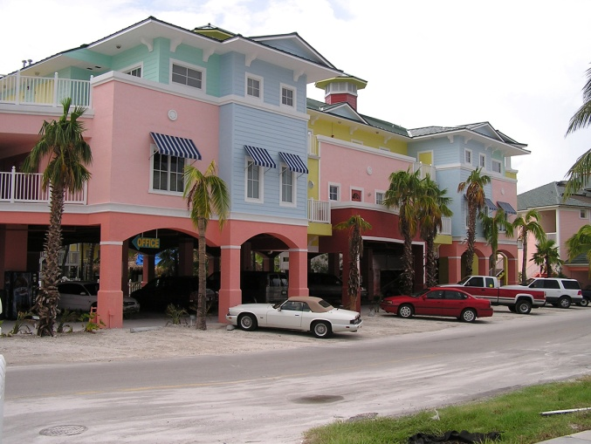
CHANGES IN VERTICAL DATUM
A FEMA requirement for all of the new FIRMs is that they be based on the vertical datum of NAVD88. Consequently, it is important that when surveys are being performed, that the [community/county’s name] new benchmarks and measurements from vertical datum NAVD88 are used—and not NGVD29—when making any site improvements.
If you are working with older plans based on NGVD29,
the Flood Insurance Study and FIRMs will provide conversion factors to make it into an equivalent
NAVD88 measurement.
CHANGES IN FLOOD
INSURANCE REQUIREMENTS
Map changes will prompt residents and business owners to re-examine the status of their properties, so that they have proper insurance coverage and can save on costs. Some properties may be identified as being in a higher risk zone or experience an increase in the BFE and the property owners will want to take advantage of the National Flood Insurance Program’s rating options to keep their costs down (e.g., Grandfathering, Newly Mapped procedure). As a result, this may generate an increase in requests for new elevation certificates. Make sure to use the latest elevation certificate form (FEMA Form 086-0-33) and to use the new vertical datum (NAVD88).
STAY INFORMED
Knowing when and where map changes are occurring allows professionals in the building industry to understand what the changes in the new maps are and what they mean. This knowledge will allow for safer construction to lower the risk of flooding and allow building to occur that will result in lower flood insurance premiums for the building’s owner. Building professionals should stay in contact with local officials as [community/county name] goes through the mapping process and know when changes in requirements for building permits will occur.
Additional information can be obtained by periodically visiting the [community or county name] web site at
[web link]. The preliminary maps can be viewed at [URL] when they are released. The maps will also be available for viewing at [put location and times it is open] once they are released. Questions can be directed to the [identify where] by calling [phone number] during business hours (days
and times).
- To learn more about the Georgia Mapping, Assessment and Planning (MAP) program, visit www.GeorgiaDFIRM.com.
- To learn more about flood insurance, visit www.FEMA.gov/NFIP.
- To download the latest version of the Elevation Certificate, visit: www.fema.gov/media-library/assets/documents/160.
Mapping Milestones
[DATE]: Preliminary flood maps released
[DATE]: Open House Held; Public Review
[DATE]: Start of [90-day] Public Comment Period [(for filing of appeals and comments)]
[Target Date, Month or Season – e.g., Fall 2018]*: New flood maps take effect; new flood insurance requirements also take effect
Visit www.GeorgiaDFIRM.com to learn more about the mapping process and where and when meetings may
be held
For General Information Call
The [name of local call center or contact number] at [phone #]. Open [enter hours of operation].
*Date subject to change pending completion of review process

