MAPPING TODAY’S FLOOD RISKS
The remapping of [county/community name] is a comprehensive effort to remap the area’s flood risks using the latest flood modeling and digital mapping technologies. The new maps, known officially as Flood Insurance Rate Maps (FIRMs), will provide detailed, property-specific flood risk data to help residents and business owners better understand their risk of flooding and guide construction and flood insurance decisions. With the planned release of these maps in [season/year], [community/county name] citizens will have up-to-date, reliable, Internet-accessible data about the flood hazards they face.
The project is part of a nationwide flood hazard map update effort spearheaded by the Federal Emergency Agency (FEMA), which also oversees the National Flood Insurance Program (NFIP). The Georgia Department of Natural Resources (GA DNR) is overseeing this remapping effort as a partner with FEMA.
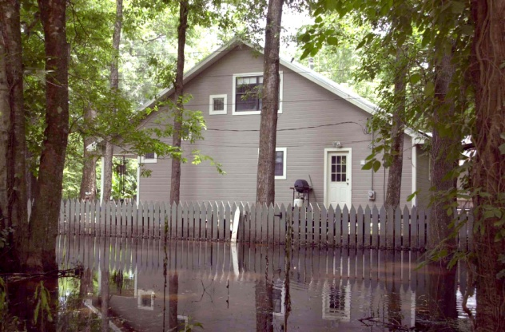
WHY UPDATE THE MAPS?
The flood maps currently in use are out of date as detailed studies have not been performed since [year]. The flood risks shown do not reflect the effects of recent growth or changes in drainage and run-off patterns caused by land-use and natural forces. The likelihood of riverine and flash flooding in some areas has increased significantly. In addition, more detailed information is now available and the technology has improved. As a result, the updated flood maps will more accurately represent these changes and the current flood risk and be an important tool in the effort to protect lives and properties in [community/county name].
NEW MAPS MEAN A
SAFER [COMMUNITY/COUNTY]
By showing the extent to which areas of the [community/county] and individual properties are at risk for flooding, the new maps will help guide financial protection, planning, investment, building, development, and renovation decisions.
- Residents and business owners will understand
their current flood risk and be able to make better decisions about insuring and protecting their property against floods.
- Builders and developers can use the updated map data to determine where and how to build structures more safely and how high to build to reduce the risk of flood damage.
- Real estate agents will be better able to inform
clients of the risk factors that may affect the property they are buying or selling as well as any flood insurance requirements.
- Insurance agents will know their clients’ current flood risk and can provide more informed recommendations regarding flood insurance coverage options.
HOW RESIDENTS AND
BUSINESSES ARE AFFECTED
Flood zone designations and base flood elevations will change with the new flood maps. Some property
owners with mortgages will face new flood insurance requirements, and people seeking to build or to substantially add to existing buildings may face new permitting and construction requirements. For example:
- If your building is re-mapped from a moderate- or low-risk flood zone to a high-risk zone, flood insurance is likely to be a requirement.
- If you already have a flood insurance policy when (or purchase before) the maps become effective, you may be able to save money on flood insurance if you maintain your policy.
- If your building is re-mapped from a high-risk zone to a moderate- or low-risk zone (labeled as an X zone), the risk of flooding is reduced, but not removed and flood insurance is still recommended.
- If you are planning new construction or improvements to your home or business, design requirements may change based on the new flood risk information.
BEFORE THE MAPS BECOME EFFECTIVE: PUBLIC COMMENT AND REVIEW
The preliminary FIRMs have been provided to [community/county name] for review. Open House[s] will be [were] held to allow residents and business owners to view the new maps and ask FEMA, GA DNR, and [county/community name] officials questions.
[INCLUDE THE FOLLOWING PARAGRAPHS IF BFEs AND/OR ZONES HAVE BEEN CHANGED IN THE COMMUNITY:]
[The next step in the process, a 90-day public comment period, gives property owners an opportunity to submit objections to information shown on the preliminary maps or in the accompanying study. Objections can be in the form of an appeal or comment.]
[An appeal must be based on data that proves that a proposed Base Flood Elevation/Base Flood Depth, flood way or flood hazard boundary shown on the preliminary flood map or in a flood insurance study report is scientifically or technically incorrect. A comment usually involves changes to items such as roads and road names, and corporate limits. During and following the 90-day public comment period, GA DNR and FEMA will review what is received and determine the merits of the comments and appeals submitted.]
[Property owners who have concerns and do not submit an objection during the public comment period can still submit a Letter of Map Amendment (LOMA) request to FEMA after the maps become effective.]
STAY INFORMED
Knowing when and where map changes are occurring allows you to be properly prepared to make important decisions. Prepare by staying in contact with local officials and periodically visiting the [community or county name] web site at [web link]. The preliminary maps can be viewed at [URL] when they are released. The maps will also be available for viewing at [put location and times it is open]. Questions can be directed to the [identify where] by calling [phone number] during business hours [days and times].
- Contact your local insurance agent to learn more about flood insurance and your options, or visit www.FEMA.gov/NFIP.
- To learn more about the Georgia Flood Mapping, Assessment and Planning (MAP) program, visit www.GeorgiaDFIRM.com.

Mapping Milestones
[DATE]: Preliminary flood maps released
[DATE]: Open House Held; Public Review
[DATE]: Start of [90-day] Public Comment Period [(for filing of appeals and comment)]
[Target Date, Month or Season (e.g., Fall 2018)]*: New flood maps take effect; new flood insurance requirements also take effect
Visit www.GeorgiaDFIRM.com [or local website] to learn more about the mapping process and where and when meetings may be held
For general information, call:
The [name of local call center or contact number] at [phone #]. Open [enter hours of operation].
*Date subject to change pending completion of review process

The Base Flood Elevation (BFE) is the level, in feet above sea level, that flood waters have a 1% annual chance of reaching or exceeding in any given year.

