AD COPY FOR AD TO RUN IN
LOCAL PUBLICATIONS
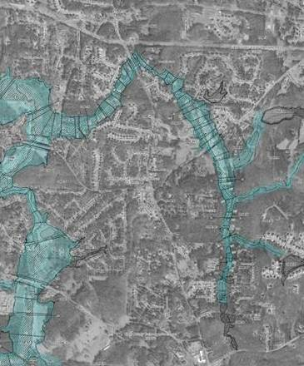
[Include an image in your ad like the example above.]
Visual
- Sample flood hazard map, 50% transparency, used as background for headlines.
Headlines
- New Flood Hazard Maps for [Name of County/Community].
- Learn your current flood risk at an upcoming Open House.
Body Copy
[Name of County’s/Community’s] flood risk information has been revised and updated flood hazard maps are now ready for review. You can view the new preliminary maps to see how your flood risk may have changed, learn how they can affect building and flood insurance requirements and find out what your options are at the following Open House[s]:
- Date, time, and location.
- [Insert schedule].
- [County name] and [community name] officials along with representatives from the Georgia Department of Natural Resources [and FEMA] will be on hand to answer questions.
- The maps will also be on display at [location] starting [date]. For more information visit [URL].
- More up-to-date flood hazard maps ultimately mean a safer more resilient [county/community name].
- Appropriate logos go at bottom.

