NEW FLOOD MAPS TO BE ISSUED
New flood hazard maps, known as Flood Insurance Rate Maps (FIRMs), will be issued and become effective on [date] for [Name] County. In cooperation with [county name], [community name] and other local communities, the maps were developed by the Georgia Department of Natural Resources (GA DNR) and the Federal Emergency Management Agency (FEMA) based on the latest digital mapping technology using the best data available.
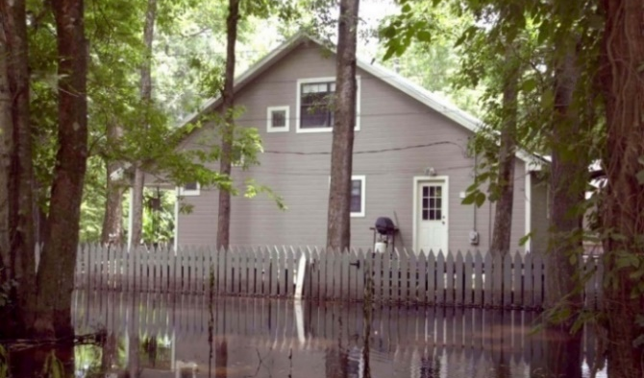
This completes a multi-year effort to update the existing flood maps that were based on data that was [number] years old and no longer represented the [community’s/county’s name] current flood risk. As part of this process, residents and business owners have had the opportunity to meet with community and GA DNR officials to discuss the maps and to provide comments. All appeals and comments have been addressed and incorporated where they provided better information than what was shown on the preliminary flood map and flood insurance study.
The new maps will show—on a property by property—the extent to which areas of the county are currently at risk for flooding. When the maps become effective, residents and business owners in many parts of the county may find that their flood risk is higher, or lower, than they thought.
CHANGES IN INSURANCE REQUIREMENTS
As the flood hazards change on the map, so will requirements for flood insurance and construction. Some property owners with mortgages that are newly mapped into high-risk areas may be required to carry flood insurance as a part of their mortgage agreement.
Property owners having to purchase flood insurance may be able to save money through cost-saving options through the National Flood Insurance Program (NFIP). For example, buildings now newly identified to be in a high-risk area may be eligible for the lower-cost Preferred Risk Policy (PRP) rates for the first 12 months after the map becomes effective. Additional savings may be realized if a PRP is purchased and effective before the new maps become effective.
Buildings mapped from a high to higher risk zone (e.g., Zone AE to Zone VE) or have an increase in Base Flood Elevation (BFE) may be able to lock in the lower risk zone or BFE for future rating (known as grandfathering).
Property owners mapped out of a high-risk flood area to a lower risk area will no longer be federally required to carry flood insurance. However, flood insurance is recommended, because the risk for flooding has only been reduced, not removed. More than 35 percent of all Georgia flood claims have occurred in areas of moderate- to low-flood risk. Most policyholders can have their existing flood insurance policy converted to the lower-cost Preferred Risk Policy, with premiums starting at less than $200 per year. Note that mortgage holders may still require flood insurance.

CHANGES IN BUILDING REQUIREMENTS
For those buildings mapped into a high-risk area from a moderate- or low-risk area, building requirements will also change. Once the new flood maps are adopted, all buildings will have to be constructed in accordance with the new flood zones and new base flood elevations shown on the map.
If a property owner still feels that their home or business should not be located in a high-risk area, they can submit a Letter of Map Change to FEMA once the new maps become effective. More information can be found at www.fema.gov/letter-map-change.

If Maps Show… | These Requirements, Options And Savings Apply
Change from moderate or low flood risk to high-risk (e.g., flood Zone B, C, or X to Zone A, AE, AH, AO[, V or VE]) | Flood insurance is mandatory. Flood insurance will be federally required for most mortgage holders. Insurance costs may rise to reflect the true (high) risk.  Rating Options can offer savings. The NFIP provides savings by allowing lower-cost Preferred Risk Policy (PRP) rates to be used the first 12 months after a new flood map becomes effective. Premiums will then increase no more than 18 percent each year. Affected property owners are encouraged to buy a PRP before the maps become effective for additional savings.
[Change from high-risk Zone A or AE to higher-risk Zone V or VE or increase in Base Flood Elevation (BFE)] | [An increase in risk can result in higher premiums; however, “grandfathering” can offer savings. The NFIP grandfathering rules allow policyholders who have built in compliance with the flood map in effect at the time of construction to keep their previous zone or BFE to calculate their insurance rate. This could result in significant savings. A grandfather-rated policy can be assigned to new owners at the time of sale.]
Change from high flood risk to moderate or low risk (e.g., flood Zone [V, VE,] A, AE, AH, AO, to Zone X or shaded X) | Flood insurance is optional but recommended. The risk has only been reduced, not removed. Flood insurance can still be obtained, and at lower rates. More than 35 percent of all Georgia flood insurance claims have occurred in moderate- and low-risk areas.  Conversion offers savings. An existing policy can be easily converted to a lower-cost Preferred Risk Policy, if the building qualifies. Note that lenders always have the option to require flood insurance in these areas.
No change in  risk level | No change in insurance rates. However, this is a good time to review your coverages and ensure that your building and contents are adequately insured.

NEW MAPS MEAN A SAFER [COMMUNITY/COUNTY]
By showing the extent to which areas of the [community/county] and individual properties are at risk for flooding, the new maps will help guide financial protection, planning, investment, building, development and renovation decisions.
- Residents and business owners will understand their current flood risk and be able to make better decisions about insuring and protecting their property against floods.
- Builders and developers can use the updated map data to determine where and how to build structures more safely and how high to build to reduce the risk of flood damage.
- Real estate agents will be better able to inform clients of the risk factors that may affect the property they are buying or selling as well as any flood insurance requirements.
- Insurance agents will know their clients’ current flood risk and can provide more informed recommendations regarding flood insurance coverage options.

STAY INFORMED
[Community/county name] are expected to pass an ordinance to adopt the new maps before the map’s effective date of [effective date]. Property owners can learn more about the flood mapping project, view the new digital flood maps at [enter URL]. Individuals with general questions about the new maps can also call [name of local call center or contact] at [phone #]. For information about flood insurance, contact your local insurance agent or visit www.FEMA.gov/NFIP.

Rates will then increase no more than 18% a year until they reach standard Zone X rates or rates equivalent to using the new maps.
The Base Flood Elevation (BFE) is the level, in feet above sea level, that flood waters have a 1% annual chance of reaching or exceeding in any given year.

