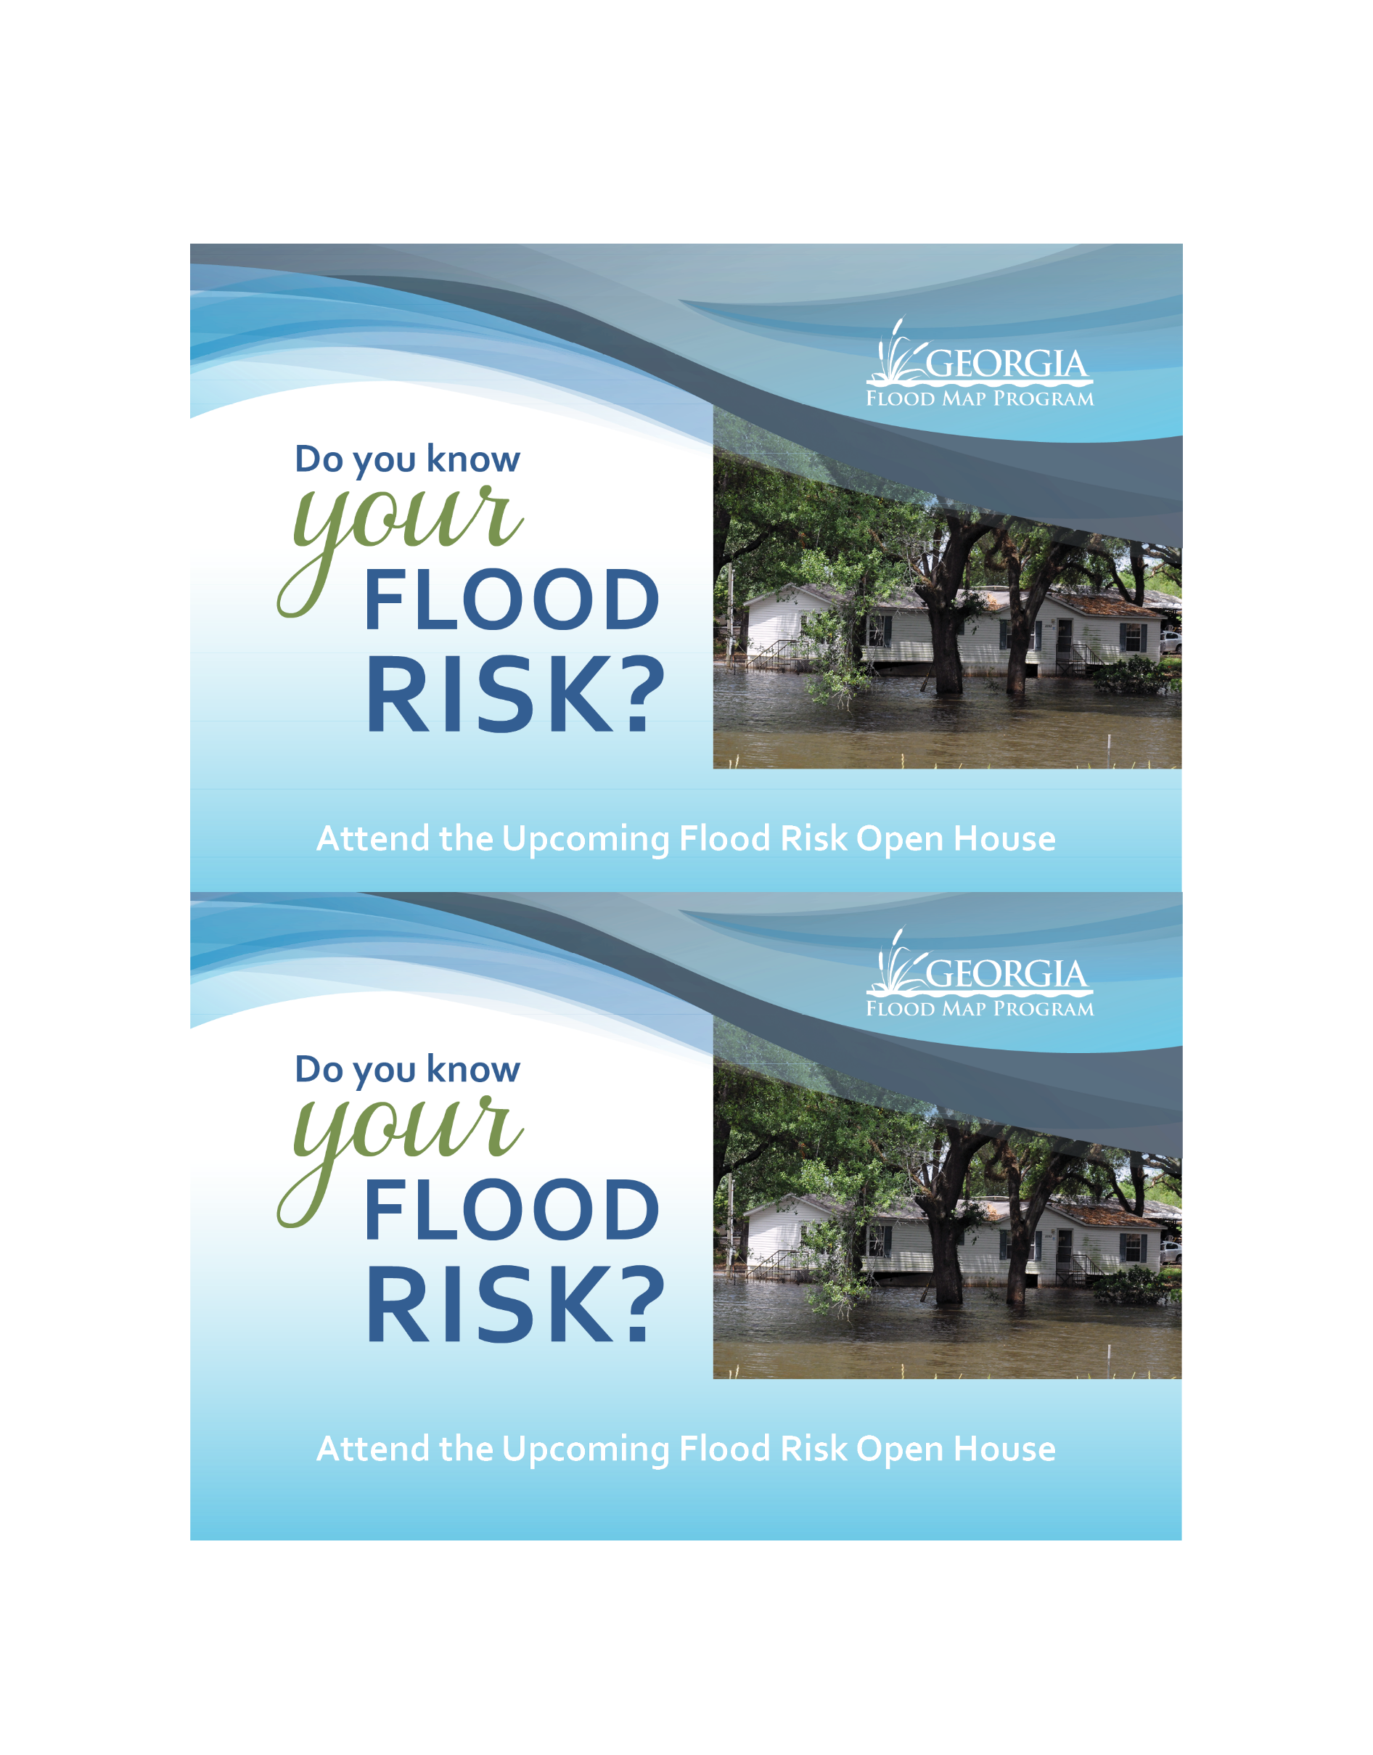

Your Community’s
Flood Maps are Changing
Your property’s flood risk may also be changing
If you have any questions about your property’s flood risk or flood insurance options, please join your community at a [virtual] Flood Risk Open House.

 |  | Flood Risk Open House  [Date]  Drop by anytime between [X p.m. & X p.m.]  [Location]  [Street]  [City/Town, GA Zip Code]  [or put details of virtual open house] |  |  |  |  | Address Here
 |  | To find out more about your flood risk, please visit www.GeorgiaDFIRM.com or contact [Local Floodplain Administrator Name] at [phone number and email address]. |  | [Community Logo]
Your Community’s
Flood Maps are Changing
Your property’s flood risk may also be changing
If you have any questions about your property’s flood risk or flood insurance options, please join your community at a [virtual] Flood Risk Open House.

 |  | Flood Risk Open House  [Date]  Drop by anytime between [X p.m. & X p.m.]  [Location]  [Street]  [City/Town, GA Zip Code]  [or put details of virtual open house |  |  |  |  | Address Here
 |  | To find out more about your flood risk, please visit www.GeorgiaDFIRM.com or contact [Local Floodplain Administrator Name] at [phone number and email address]. |  | [Community Logo]

