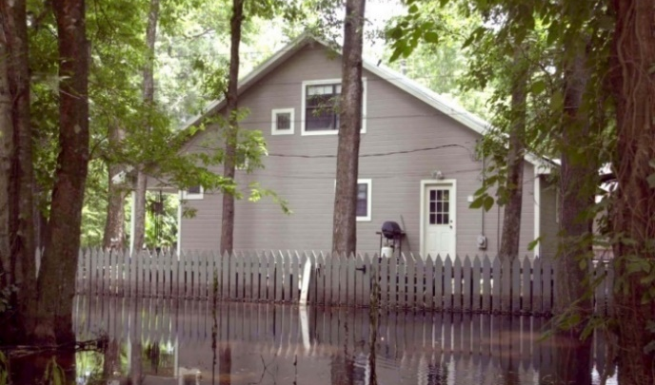
NEW FLOOD MAPS TO BE ISSUED

New flood hazard maps, known as Flood Insurance Rate Maps (FIRMs), are being issued for your county. In cooperation with your community and other local communities, the Georgia Department of Natural Resources (GA DNR) and the Federal Emergency Management Agency (FEMA) developed the maps. They are based on the latest digital mapping technology using the best data available.
This completes a multi-year effort to update the existing flood maps that were developed using older data and no longer represented your community’s current flood risk. As part of this process, residents and business owners have had the opportunity to meet with community and GA DNR officials to discuss the maps and to provide comments. All appeals and comments have been addressed and incorporated where they provided better information than what was shown on the preliminary flood map and flood insurance study.
The new maps will show—on a property-by-property basis—the extent to which areas of the county are currently at risk for flooding. When the maps become effective, residents and business owners in many parts of the county may find that their flood risk is higher, or lower, than they thought.
CHANGES IN FLOOD INSURANCE REQUIREMENTS
As the flood hazards change on the map, so will requirements for flood insurance and construction. Some property owners with mortgages that are newly mapped into high-risk areas may be required to carry flood insurance as a part of their mortgage agreement.
Property owners having to purchase flood insurance may be able to save money through a cost-saving option through the National Flood Insurance Program (NFIP). For example, buildings now newly identified to be in a high-risk may be eligible for a Newly Mapped discount if flood insurance is purchased within the first 12 months after the map change is effective. Premiums will then go up no more than 18% each year until they reach full-risk rate. If the building is sold, the NFIP policy can be transferred to the new owner. This allows the new owner to continue to get the benefit of this rating option if the premium has not reached the full-risk rate.
The mapping of buildings from a high to higher risk zone (e.g., Zone AE to Zone VE) or have an increase in Base flood Elevation (BFE) does not affect the full-risk premium. This is because all NFIP flood insurance rates are determined based on your property’s unique flood risk, regardless of flood zone or BFE.
Buildings no longer identified to be in a high-risk flood area but in a lower risk area will no longer be federally required to carry flood insurance. While flood insurance costs may not change, flood insurance is still recommended, because the risk for flooding has only been reduced, not removed. More than 35 percent of all Georgia flood claims come from policyholders in areas of moderate- to low-flood risk Note that mortgage holders may still require flood insurance.
CHANGES IN BUILDING REQUIREMENTS
For those buildings newly identified to be in a high-risk area, which were previously in a moderate- or low-risk area, building requirements will also change. Once the new flood maps are adopted, all buildings will have to be constructed in accordance with the new flood zones and new Base Flood Elevations shown on the map.

If a property owner still feels that their home or business should not be located in a high-risk area, they can submit a Letter of Map Change to FEMA once the new maps become effective. More information can be found at www.fema.gov/flood-maps/change-your-flood-zone/loma-lomr-f.
NEW MAPS MEAN A SAFER COMMUNITY
By showing the extent to which areas of the county and individual properties are at risk for flooding, the new maps will help guide financial protection, planning, investment, building, development and renovation decisions.
- Residents and business owners will understand their current flood risk and be able to make better decisions about insuring and protecting their property against floods.
- Builders and developers can use the updated map data to determine where and how to build structures more safely and how high to build to reduce the risk of flood damage.
- Real estate agents will be better able to inform clients of the risk factors that may affect the property they are buying or selling as well as any flood insurance requirements.
- Insurance agents will know their clients’ current flood risk and can provide more informed recommendations regarding flood insurance coverage options.

STAY INFORMED
Your community is expected to pass an ordinance to adopt the new maps before the map’s effective date. Property owners can learn more about the flood mapping project, view the new digital flood maps at www.georgiadfirm.com. Individuals with general questions about the new maps can also call their community’s floodplain administrator. For information about flood insurance, contact your local insurance agent or visit www.FloodSmart.gov.

The Base Flood Elevation (BFE) is the level, in feet above sea level, that flood waters have a 1% annual chance of reaching or exceeding in any given year.

